Aboveground biomass in *Salix richardsonii* is predicted by canopy height but not by greenness (NDVI)

Contributors

Andrew M. Cunliffe1,2*, Jakob Assmann2,3, Gergana Daskalova2, Jeff Kerby4, Isla H. Myers-Smith2

Affiliations

1 Department of Geography, University of Exeter, UK

2 School of Geosciences, University of Edinburgh, UK

3 Department of Bioscience, Aarhus University, DK

4 Aarhus Institute of Advances Studies (AIAS), Aarhus University, DK

* Corresponding author ([a.cunliffe@exeter.ac.uk](mailto:a.cunliffe@exeter.ac.uk))

ORCID

AMC: 0000-0002-8346-4278; IHM-S: 0000-0002-8417-6112; JA: 0000-0002-3492-8419; GD: 0000-0002-5674-5322; JK: 0000-0002-2739-9096

Keywords

Vegetation Change; Aboveground biomass; Shrubs; Environmental Monitoring; Drones; Arctic Ecosystems; Proximal Remote Sensing; Structure-from-Motion Photogrammetry

Aiming to submit this to the [ABoVE special issue](https://iopscience.iop.org/journal/1748-9326/page/ABoVE) in **Environmental Research Letters.**

**Abstract**

Drone-acquired measurements of ecological metrics such as vegetation canopy structure and spectral reflectance can support scaling of ecological relationships from plots to biomes. However, there are substantial gaps in our knowledge of how drone-acquired remote sensing observations correspond with other properties of ecosystems such as estimates of vegetation ‘greenness’ and biomass. Here, we address this knowledge gap by conducting peak-season surveys of spectral reflectance measured with a drone-mounted sensor, canopy height from drone photogrammetry and on-the-ground point framing, and aboveground biomass from harvest plots. We worked across a willow (*Salix richardsonii*) shrub-dominated alluvial fan, at a focal study site in the tundra biome – Qikiqtaruk - Hershel Island in the Canadian Arctic.

We found strong agreement between canopy heights measured using *in-situ* point framing compared to drone-photogrammetry (concordance correlation coefficient of 0.808), although the photogrammetry observations were positively biased relative to the point framing. Canopy height was strongly and linearly related to aboveground biomass, with similar coefficients of determination for both point framing (R2 = 0.92) and drone-based methods (R2 = 0.90). However, we found poor correspondence between aboveground biomass and vegetation ‘greenness’ measured as the normalised difference vegetation index (NDVI) across four independent multispectral surveys.

Our findings demonstrate the reliability of canopy height measured with drone photogrammetry and aboveground biomass inferred from fine-scale canopy height observations collected with either ground- or drone-based methods. We also highlight the difficulties with estimating aboveground biomass over fine spatial grains using vegetation indices such as NDVI, and suggest caution with attributing change in these indices to biomass differences alone. By comparing structural, spectral and on-the-ground ecological measurements, we can improve our understanding of tundra vegetation change as inferred from remote sensing.

# Introduction

Arctic ecosystems are warming rapidly (IPCC, 2013) and plant communities are responding (Elmendorf et al., 2015, 2012; Myers-Smith et al., 2019, 2011), yet understanding of the controls on vegetation change in tundra plant communities is limited. Shrub growth is climate sensitive (Myers-Smith et al., 2015), and increases in shrub abundance and decreases in bare ground in plant communities have been reported at sites around the tundra biome (Elmendorf et al., 2012; Myers-Smith et al., 2011). However, we do not yet have standardized methods of quantifying changes in tundra plant community structure and growth across the landscape. One of the key challenges in tundra ecological monitoring is acquiring scale-appropriate observations due to the small growth form of many plants in this large and often inaccessible biome (Fisher et al., 2018).

In tundra ecosystems, there is an critical scale gap between *in-situ* observations collected at fine spatial scales and biome-wide coarse scale observations from satellite based remote sensing (Myers-Smith et al., 2020; Riihimäki et al., 2019). Bridging this scale gap requires integration of remotely sensed observations at intermediate scales, and unmanned aerial vehicles (UAVs, described hereafter as drones) are one possible platform for deploying sensors across these levels (Anderson, 2016). Drones are now widely used for collecting environmental data, however, empirical work is needed to relate remotely sensed attributes to ecological functions in order to inform scientific interpretations. For example, Berner *et al*. (2015) highlighted the lack of allometric relations relating observable plant dimensions to aboveground biomass in Arctic ecosystems. Fraser *et al*. (2016) and Cunliffe *et al*. (2016) demonstrated the potential for drone photogrammetry to measure canopy heights in low-stature ecosystems, but highlighted lack of empirical work to relate canopy height to plant biomass for other taxa.

Vegetation indices can be calculated from spectral reflectance measurements, for example the normalised difference vegetation index (NDVI) which is a widely used indicator of photosynthetic capacity of plant canopies. Several studies have shown that NDVI can be good predictor of phytomass biomass in Artic ecosystems (Boelman et al., 2003; Walker et al., 2003), and NDVI has often also been considered a predictor of total aboveground biomass. However, in many communities non-photosynthetic components dominated aboveground biomass (Epstein et al., 2012), and few empirical studies have tested the relationship between NDVI and *total* aboveground biomass (Berner et al., 2018; although see Boelman et al., 2003; Goswami et al., 2015). Furthermore, there is normally a scale miss-match between the extents sampled for spectral reflectance (i.e. the ground sampling distance of a remotely sensed pixel) and the extents over which aboveground biomass is quantified. Given the widespread consideration of NDVI as a predictor of total aboveground biomass combined with the increasing accessibility of spectral reflectance data at ever-finer spatial resolutions (Berner et al., 2018; Fraser et al., 2017; Riihimäki et al., 2019), there is a need to evaluate the capacity of NDVI to explain variation in total biomass for a wider range of Arctic tundra communities.

We combined these research priorities by conducting spatially explicit comparisons between ground-based and UAV-based measurements of canopy height, NDVI, and biomass. We worked across a *Salix richardsonii* dominated graminoid to shrub ecotone to examine whether drone data collection and image-based modelling approaches can yield high-fidelity measurements of vegetation attributes. We tested (i) the correspondence of canopy height models derived from aerial photogrammetry relative to *in-situ* point framing methods, (ii) how well canopy height predicts aboveground biomass, and (iii) how well NDVI values obtained at different spatial grains correspond to observations of total biomass, photosynthetic biomass and leaf biomass.

# Methods

## Site description

We conducted our study on Qikiqtaruk - Herschel Island in the Canadian Arctic. Tundra vegetation communities here range from graminoid- to shrub-dominated and are underlain by organic soils and ice-rich permafrost. This site has undergone marked ecological changes in community composition, increases in canopy height and vegetation abundance, decreases in bare ground, and an advance in leaf emergence and flowering over the 18 years of ecological monitoring to date (Myers-Smith et al., 2019). We established a ca. 2 ha-1 study site across a graminoid-shrub ecotone at the edge of a wet willow shrub-dominated alluvial fan (69.34°N, 138.53°W) (Figure 1).

To constrain the photogrammetric modelling and locate the point clouds in a coordinate reference system, 26 ground control markers (265 mm x 265 mm) were deployed across the site and geolocated to a relative 3D accuracy of ≤ 0.015 m with RTK-GNSS equipment (Leica GS10). Coordinates were relative to a local benchmark, geolocated in absolute terms to ±0.003 m in X and Y, and ±0.008 m in Z (95% confidence interval), using the AUSPOS web service. The markers were situated to be visible from the air, and a high density of markers facilitated image alignment in the texturally complex scenes. We selected 36 square plots of 50 cm × 50 cm for harvesting in June 2016. All plots were chosen so that they contained no standing water at that time. The plots were arranged in twelve blocks of three replicates across the range of canopy heights to enable a detailed assessment of the form of the allometric relationships. The corners of each harvest plot were precisely geolocated using the GNSS. To minimise sinkage of the GNSS survey staff into the often-soft ground, we used a ca. 25 cm2 ‘foot’ on the bottom of the staff to dissipate pressure.

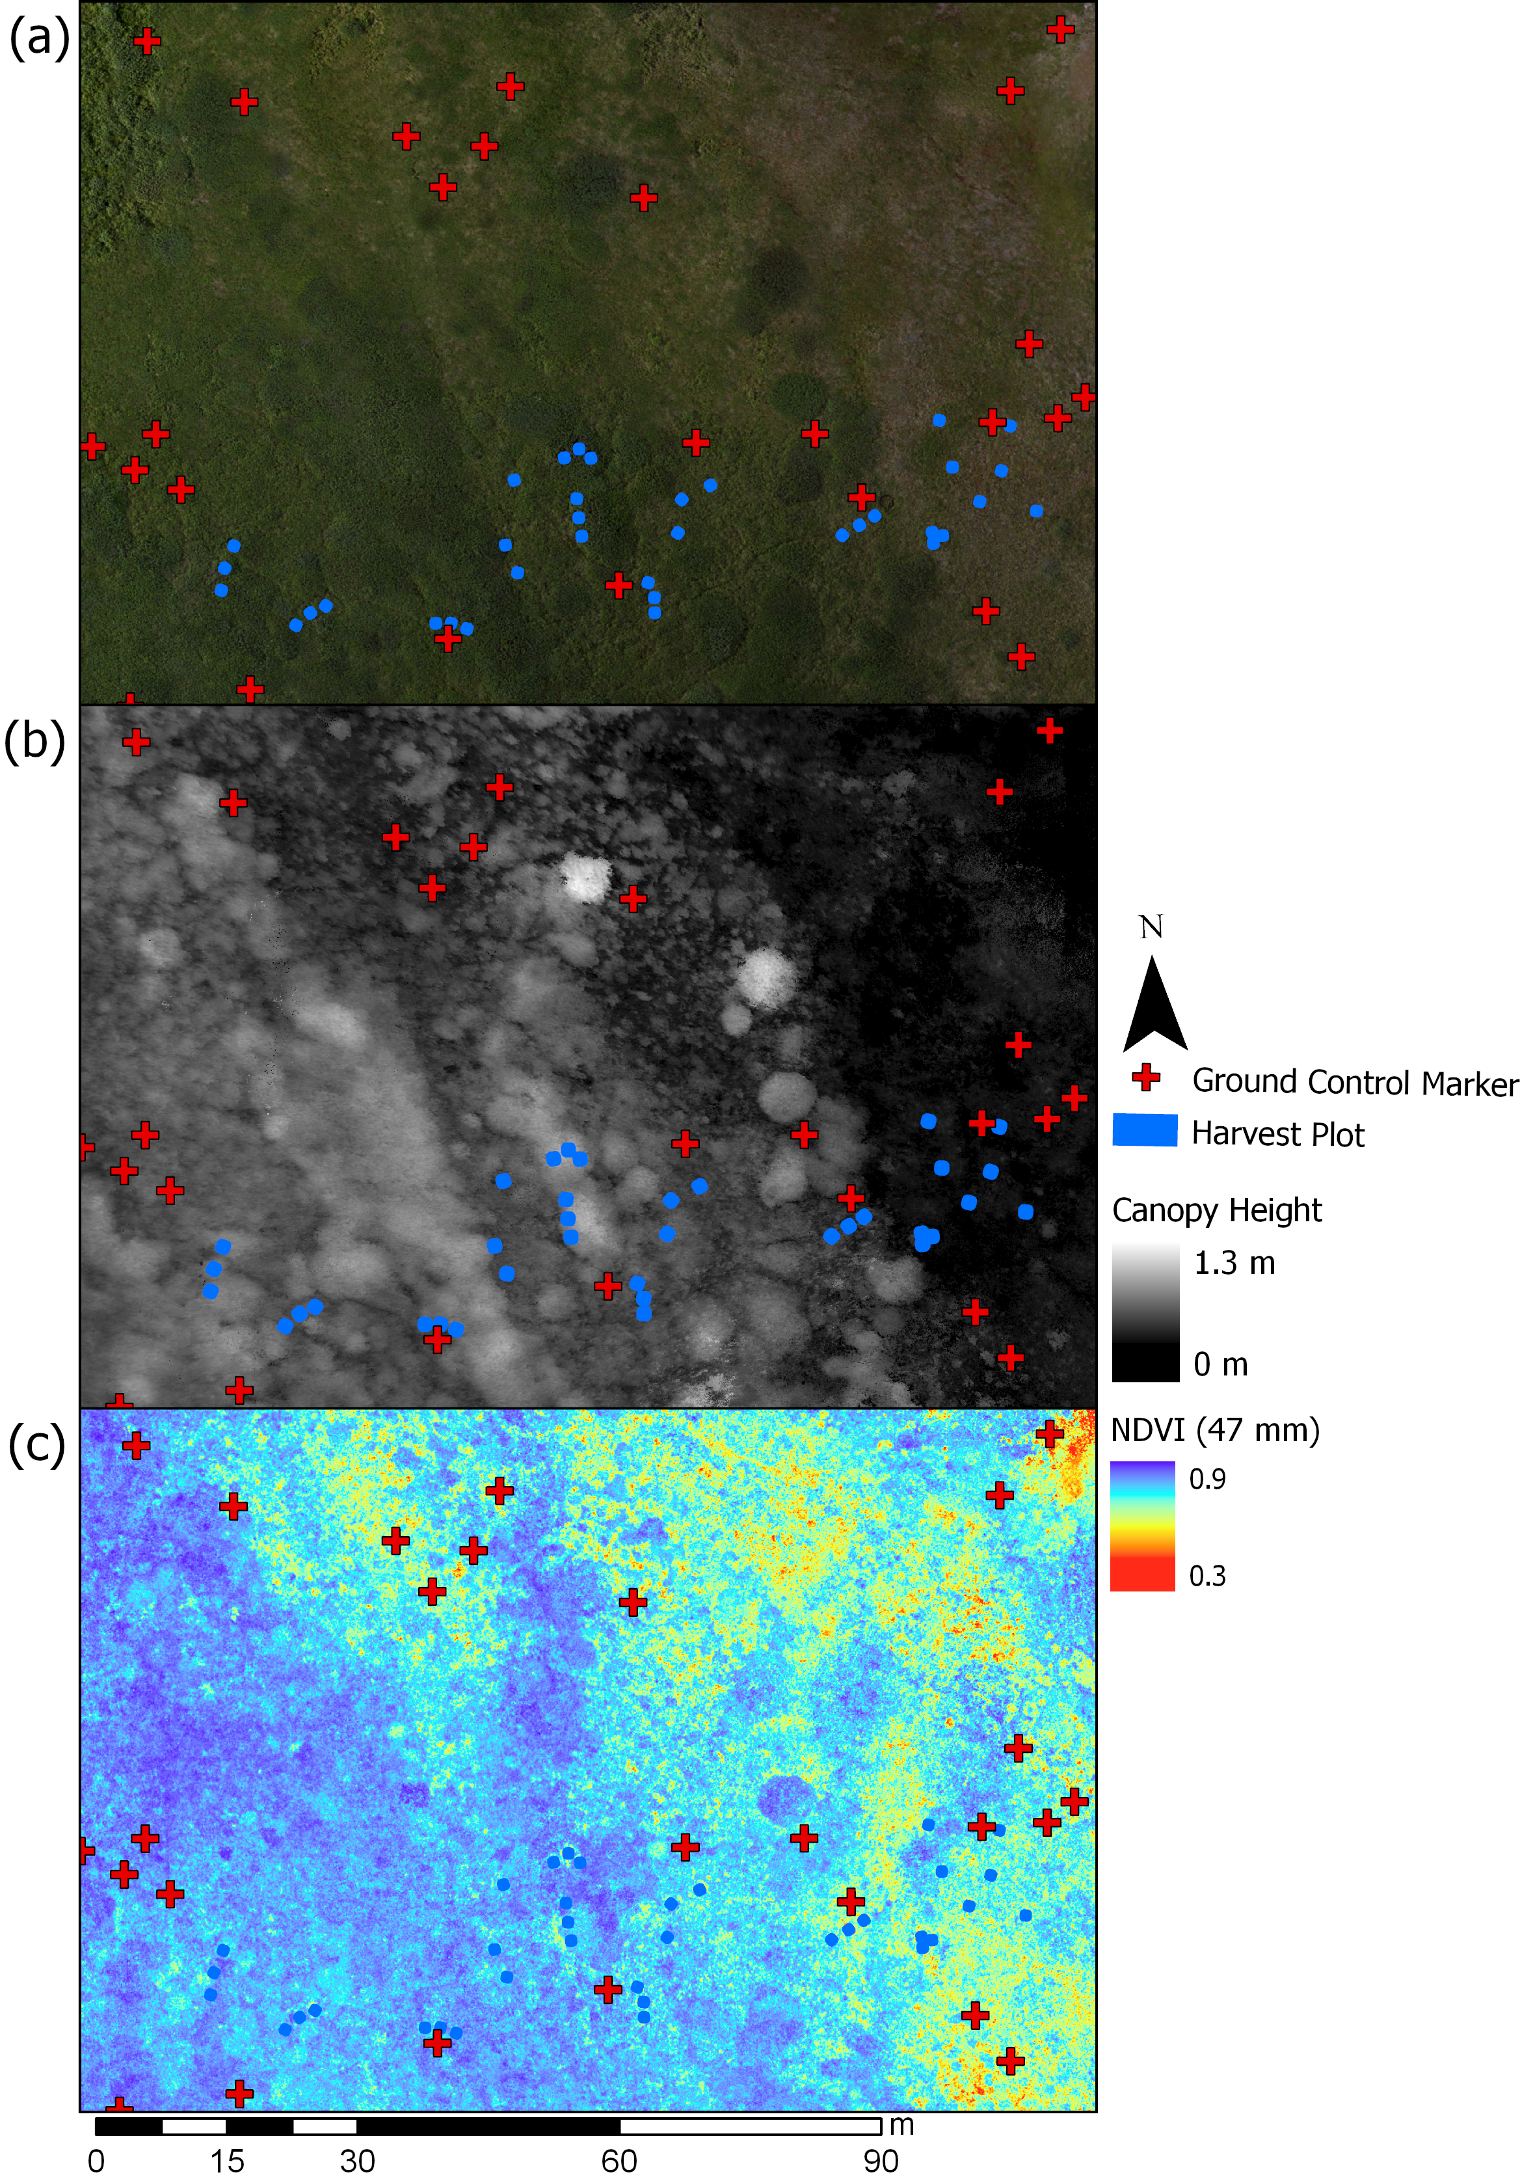

Figure 1. Overview of the study site encompassing a graminoid-shrub ecotone. (a) True colour orthomosaic at 4 mm spatial resolution, (b) structure-from-motion derived canopy height map at 0.01 m spatial grain, and (c) map of NDVI values at 0.047 m spatial grain. The locations of the ground control markers (red crosses, n=26) and harvest plots (blue squares, n=36) are also indicated.

## Aerial surveys

## Aerial survey for canopy height modelling

To obtain aerial images for modelling canopy heights, we used a 24 megapixel camera (Sony α6000), equipped with a prime lens (Sony SEL 20 mm F2.8), carried on a Tarot hexacopter controlled with a PixHawk running open source ArduPilot (<http://ardupilot.org>) software (Table 1). Two sets of survey flights were undertaken, the first obtaining nadir imagery and the second obtaining oblique (ca. 20° from nadir) images with a spatial grain of ca. 4-6 mm at the canopy top (Cunliffe and Anderson, 2019). The camera was triggered by the flight controller based on distance travelled, with both sets of flights together capturing ≥ 22 photos for every part of the study area (equivalent to forward overlap of 75% and sidelap of 65% for each flight). We collected 673 RGB photographs over our survey area. Mission flight speeds ensured that motion blur during shutter exposure was less than half of the ground sampling distance. Image data were originally recorded in lossless RAW format (Sony ARW), and were converted to uncompressed TIFF using Sony’s Image Data Converter(v4).

## Aerial survey for spectral reflectance

To obtain images for modelling spectral reflectance, we used Parrot Sequoia multispectral sensors (firmware 1.0.0), mounted on a multi-rotor (as above) and flying-wing (Zeta Phantom FX-61) platforms with PixHawk flight controllers. We undertook four multispectral surveys over two days, at altitudes of 19 m, 50 m, 120 m and 121 m above ground level, to sample a range of spatial resolutions and illumination conditions with respect to cloud cover and sun illumination angle (Table 1). The three multirotor flights carried the same Sequoia sensor, while the flying-wing carried a second Sequoia sensor. A MicaSense spectral reflection calibration panel reflecting ca. 50% of light was photographed before and after each survey, and the image considered to be the most representative of illumination conditions during the survey was used to calibrate the spectral reflectance during processing (Assmann et al., 2018). The reflectance values of the panel were measured under laboratory conditions before and after the field campaign, and we used the mean of these two measurements to minimise errors arising from degradation in panel reflectance. The Sequoia was triggered using a two-second intervalometer to achieve an overlap of at least five images across the area of interest. Our sampling at the end of July coincided with the peak growing season at this location.

Table 1. Parameters from drone surveys. (A) and (B) refer to the two Parrot Sequoia sensors, and local time refers to the centre of the survey period.

|  |  |  |  |  |  |  |  |  |
| --- | --- | --- | --- | --- | --- | --- | --- | --- |
| **Sensor** | **Altitude agl [m]** | **GSD [m]** | **Date** | **Local time (UTC-8)** | **Solar elevation**  **(degrees)** | **Platform** | **Mean wind speed [m s-1]** | **Cloud conditions** |
| Sony α6000 | 19 | 0.005 | 25th July 2016 | 13:20 | 39.9 | Multirotor | 3.4 | Thin cirrus (sun not obscured) |
| Parrot Sequoia (A) | 19 | 0.018 | 26th July 2016 | 17:34 | 27.3 | Multirotor | 3.1 | Thin cirrus (sun not obscured) |
| Parrot Sequoia (A) | 50 | 0.047 | 30th July 2016 | 13:10 | 38.7 | Multirotor | 4.2 | Scattered cumulus (sun not obscured) |
| Parrot Sequoia (B) | 120 | 0.119 | 30th July 2016 | 13:21 | 38.7 | Flying-wing | 4.9 | Cumulus (sun obscured) |
| Parrot Sequoia (A) | 121 | 0.121 | 26th July 2016 | 19:50 | 15.6 | Multirotor | 3.1 | Scattered cumulus (sun not obscured) |

## Image based modelling

## Processing for canopy height models

The aerial images were processed using structure-from-motion photogrammetry on a high performance workstation with a workflow based on Cunliffe *et al*. (2016). Geotagged image data and marker coordinates were imported into Agisoft PhotoScan (v1.2.4) and converted into a common coordinate reference system (WGS84 UTM 7N; EPSG:32607). Image sharpness was assessed using PhotoScan’s image quality tool, which assesses the sharpness of the sharpest part of each photograph; all images had a sharpness of ≥ 0.77. Photos were matched and cameras aligned, using the highest quality setting, key point limit of 100,000; unlimited tie points, generic and reference pair preselection enabled, and adaptive camera model fitting disabled. Camera location accuracy was set to 25 m, marker location accuracy was set to 0.01 m, marker projection accuracy was set to 2 pixels, and tie point accuracy was set to 1.

The sparse cloud was filtered and tie points with reprojection error above 0.55 were excluded from further analysis. An operator reviewed the estimated camera positions to verify their plausibility and remove any obviously erroneous tie points from the sparse cloud. Geolocated markers were manually placed on all projected images for each of the 26 ground control points (Cunliffe et al., 2016; Kachamba et al., 2016). Three markers used for independent accuracy assessment were deselected at this stage. The bundle adjustment was then optimised using the filtered cloud of tie points and the following lens parameters: Focal length (f), principal point (cx, cy), radial distortion (k1, k2, k3), tangential distortion (p1, p2), and aspect ratio and skew coefficients (b1, b2). Out of 673 images, 95% (636) were aligned and used for the multi-view stereopsis (dense cloud generation) using the ultrahigh quality setting, mild depth filtering and point colour calculation enabled. The dense point cloud was exported in the laz format, with point coordinate and RGB attributes.

The dense point cloud was analysed in PDAL (v1.9.1 PDAL Contributors, 2019). The corner coordinates were used to subset points for each harvest plot. Within each plot, the normalised height above ground (hereafter height) of each point was calculated relative to the horizontally closest corner coordinate. Any points with a negative height above ground were coerced to zero. In a few instances where corner marker posts were visible in the point cloud, these points were removed manually. We determined the maximum height for each cell across a fine grid with a spatial resolution of 0.01 m using the rasterstats package (v0.13.1). For cells containing no points, maximum heights were interpolated with inverse distance weighting considering an array of 11x11 cells using a power term of two, and cells with no neighbouring points in that area remained empty. We used the 1 cm spatial grain to preserve the fine-scale variability in the point cloud (Cunliffe et al., 2016; Wallace et al., 2017). Plot-level summary metrics were then extracted from this grid of local maxima elevations.

## Processing for spectral reflectance

The multispectral images were processed using Pix4Dmapper Pro (v4.0.25). Radiometric corrections were implemented using dowelling sun irradiance and pre- or post-flight images of reflectance panels following Assmann *et al.* (2018). Ground control markers were manually placed in ≥15 images, and then automatic placement was employed and manually verified. Normalised difference vegetation index (NDVI) maps were generated using the ‘AG Multispectral Template’ at the native resolution of the GSD (Table 1). The R Package ‘exactextractr’ (Baston, 2019, v0.1.1) was used to extract the mean NDVI of each plot.

## *In-situ* point framing

Each of the 36 50x50 cm plots was surveyed using point-intercept methodologies similar to ITEX protocols (Molau and Mølgaard, 1996; Myers-Smith et al., 2019), on the 30th and 31st of July 2016. To do this, a grid with 36 points at 10 cm intervals was placed over each plot. At each point, a metal pin was placed vertically and the maximum height of the canopy above the moss/litter layer, as a pseudo-ground surface, was recorded.

## Biomass harvest

Within each of the 36 sub-plots, all standing vascular plants were harvested down to the moss/litter layer (after Walker et al., 2003) on the 31st of July and 1st of August 2016. Harvested biomass was separated into three partitions: (i) woody stems, (ii) shrub leaves (including catkins), and (iii) herbaceous material (consisting of mainly graminoids and equisetum but also some forbs). Biomass was dried at ca. 35°C for ≥ 70 hours, until at a constant weight (<0.2% change) over a 24-hour period. To quantify biomass carbon contents, subsamples of each partition from 12 plots were oven-dried at 70°C for 48 hours, homogenised for a fine powder with a ball mill, and flash combusted for measurement of evolved CO2 in an elemental analyser (CE Instruments, NC2500).

## Statistical analysis

Statistical analysis was completed in R (v3.6.1) (R Core Team, 2019). Solar elevations were calculated using the ‘suncalc’ package (Thieurmel and Elmarhraoui, 2019).To compare agreement between point framing and structure-from-motion metrics of canopy height, we calculated concordance correlation coefficients using the ‘DescTools’ package (after Lin, 1989) and we described this relationship with a power model fitted with ordinary least squares regression because using a positive exponent means the model passes through the origin. We used least squares optimisation to fit linear models between canopy height and aboveground biomass, with intercepts constrained through the origin as plants with zero height above ground have no biomass above ground. Constraining model intercepts made only a small difference to model slopes (Table S1). We used nonlinear least squares optimisation to fit exponential models to NDVI and three biomass pools: (i) total aboveground biomass, (ii) phytomass (calculated as the sum of shrub leaves and herbaceous material), and (iii) the mass of shrub leaves.

# Results

We found strong agreement between canopy heights as observed with point framing techniques and structure-from-motion photogrammetry (concordance correlation coefficient = 0.79, with 95% confidence intervals (CI) 0.68 to 0.86, Figure 2 and S1). The photogrammetry canopy heights had a consistent positive bias relative to point framing heights with a median average of 0.14 ± 0.05 m (± SD). Differences in mean canopy height between methods were smaller for the shortest and tallest plots, and greatest for the plots of intermediate heights (Figure S1).

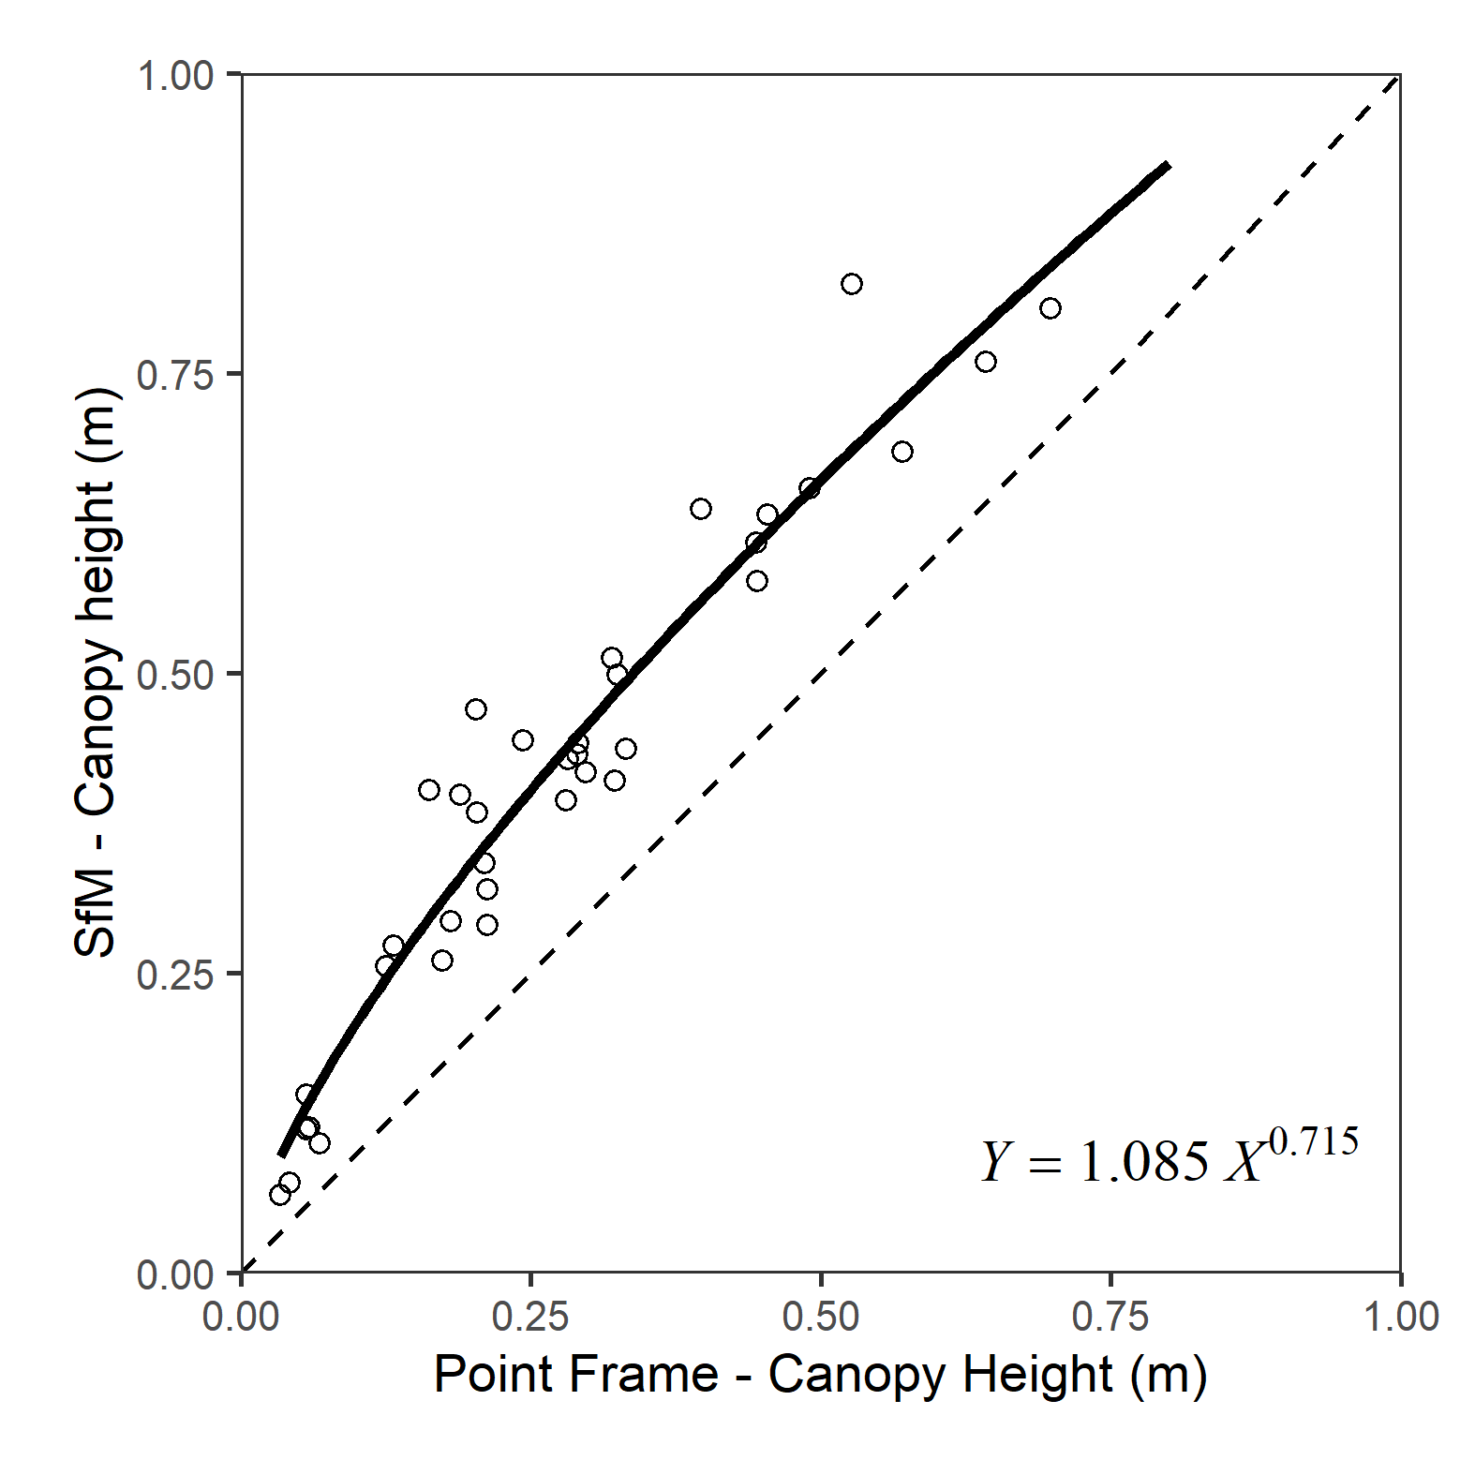

Figure 2. Canopy heights observed with point framing were positively correlated with canopy heights observed with structure-from-motion photogrammetry (SfM). The dotted line shows the 1:1 relationship for reference and the solid line is a power model. Canopy heights measured with SfM were consistently positively biased by on average 0.14 m relative to canopy heights measured with point framing.

We found canopy height explained high proportions of the variation in aboveground biomass across the *Salix richardsonii*-dominated graminoid-shrub ecotone (R2 = 0.92 and R2 = 0.90 for the point framing and photogrammetry methods, respectively (Figure 3). Total aboveground biomass within the sampled plots ranged from 149 g m2 to 2,431 g m2 with a mean of 1012 ± 699 g m2 (SD).

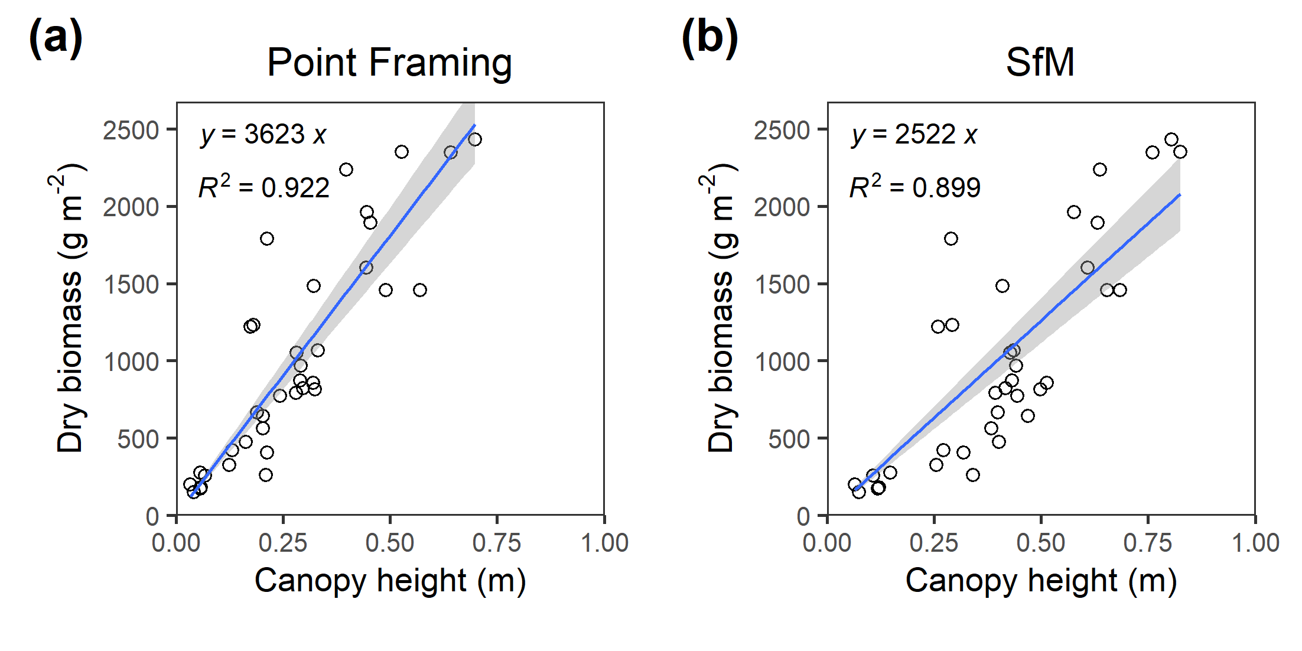

Figure 3. Aboveground biomass was strongly predicted by canopy height. Mean canopy height for each plot was measured with (a) point framing and (b) structure-from-motion photogrammetry. Linear models with constrained intercepts were fitted with least mean squares regression.

Mean NDVI was only weakly related to total aboveground biomass, phytomass or the mass of shrub leaves (Figure 4, Table 2). The fitted exponential models indicated positive relationships with a near-linear form across the observed inference space, but explained little of the variance in total aboveground biomass, phytomass or shrub leaf biomass. This finding was consistent across each of the four NDVI datasets analysed (0.121, 0.191, 0.047 and 0.018 m ground sampling distances). Residual standard error increased as spatial grain became finer for all three biomass pools (Table 2). The strongest relationships were seen with the coarsest spatial grain of NDVI (0.121 m) and the biomass of the shrub leaves, but this component generally accounted for less than 10% of the total biomass.

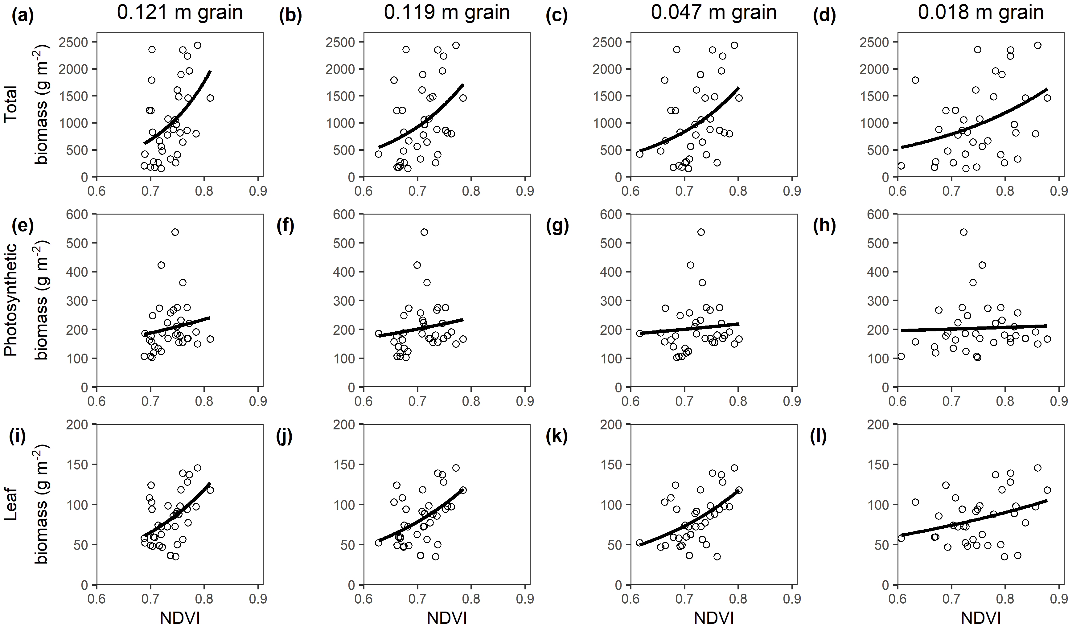

Figure 4. Mean NDVI is only moderately related to total biomass, phytomass or leaf biomass at the plot level. NDVI explained very little of the variance in total aboveground biomass across all four spatial grains investigated (a), (b), (c) and (d). NDVI also explained very little of the variance in photosynthetic biomass, calculated as the sum of shrub leaves and herbaceous material (e), (f), (g) and (h). NDVI did explain slightly more of the variance in leaf biomass; however, the relationships were still weak and leaf biomass typically accounted for less than 10% of total biomass (i), (j), (k) and (l). Black lines are exponential models, described in Table 2.

Table 2. Parameters of models fitted to mean plot normalised difference vegetation index (NDVI) and total aboveground biomass, phytomass (leaf + herbaceous), and leaf biomass.

|  |  |  |  |  |  |
| --- | --- | --- | --- | --- | --- |
| Dependent variable | grain of NDVI in m | Model form | a | b | Residual standard error |
|  |  |  |  |  |  |
| Total biomass | 0.121 | Y = a e(b X) | 0.90 ± 2.19 | 9.48 ± 3.22 | 634.3 |
| Total biomass | 0.119 | Y = a e(b X) | 5.62 ± 11.82 | 7.29 ± 2.89 | 648.6 |
| Total biomass | 0.047 | Y = a e(b X) | 7.46 ± 15.14 | 6.74 ± 2.72 | 652.5 |
| Total biomass | 0.018 | Y = a e(b X) | 46.04 ± 63.15 | 4.06 ± 1.74 | 656.1 |
| Phytomass | 0.121 | Y = a e(b X) | 38.92 ± 68.26 | 2.25 ± 2.37 | 89.5 |
| Phytomass | 0.119 | Y = a e(b X) | 58.29 ± 81.61 | 1.77 ± 1.96 | 89.6 |
| Phytomass | 0.047 | Y = a e(b X) | 108.33 ± 139.84 | 0.88 ± 1.78 | 90.5 |
| Phytomass | 0.018 | Y = a e(b X) | 164.35 ± 145.32 | 0.29 ± 1.17 | 90.8 |
| Leaf biomass | 0.121 | Y = a e(b X) | 1.00 ± 1.28 | 5.97 ± 1.72 | 27.0 |
| Leaf biomass | 0.119 | Y = a e(b X) | 2.49 ± 2.65 | 4.92 ± 1.47 | 27.1 |
| Leaf biomass | 0.047 | Y = a e(b X) | 2.74 ± 2.70 | 4.69 ± 1.34 | 26.7 |
| Leaf biomass | 0.018 | Y = a e(b X) | 18.85 ± 13.67 | 1.95 ± 0.94 | 29.4 |

Where ± refers to the standard error of the parameter and n = 36 in all cases.

# Discussion

We found that canopy heights across a graminoid-shrub ecotone could be measured over fine (cm) spatial scales using structure-from-motion photogrammetry, and that measured heights corresponded strongly with those obtained from using more conventional point framing techniques (Molau and Mølgaard, 1996; Myers-Smith et al., 2019). Canopy heights were positively correlated with biomass, indicating that photogrammetry-derived data can be used to estimate aboveground tundra biomass. However, vegetation greenness as measured by NDVI did not correspond with biomass observations. Our findings suggest that at fine-scales there is not a strong relationship between NDVI and biomass. Our study highlights that drone-derived canopy height and biomass estimates could help inform monitoring of vegetation change and improve projections of plant responses to warming in tundra ecosystems.

*Photogrammetry derived canopy heights were taller than* in situ *measured canopy heights*

We attribute the bias in canopy heights to differences that canopy architectures are measured by the two approaches. The photogrammetry-derived heights may have also been slightly exaggerated by slight depression of the moss ‘ground’ surface (ca. 2 - 3 cm) at the plot corners by the GNSS survey staff. Similar good correspondence between in-situ versus photogrammetrically-derived *maximum* canopy heights has also been reported for 20 shrubs measured at an arctic tundra site near Cambridge Bay (Clement and Fraser, 2017). However, such comparisons are hindered by the sensitivity of maximum height measurements to outliers in these often noisy point clouds (Cunliffe et al., 2016). Photogrammetrically-derived canopy heights are sensitive to the ways in which raw data are acquired, processed and analysed (Cunliffe et al., 2016; Fraser et al., 2019; Wallace et al., 2017), but our findings suggest that, when applied in a consistent manner, drone photogrammetry is an appropriate tool for monitoring shrub canopy heights.

*Canopy heights predict aboveground biomass*

Our finding that canopy height strongly predicted aboveground biomass for this *Salix-richardsonii* community corroborates similar reports for photogrammetry across a range of biomes and plant communities (Bendig et al., 2015; Grüner et al., 2019; Selsam et al., 2017; Wijesingha et al., 2018). Estimating aboveground biomass on the basis of canopy height models is highly dependent on having an underlying terrain model of sufficient quality to describe topographic variability (Cunliffe et al., 2016; Fraser et al., 2019; Kachamba et al., 2016). In this study, we derived our terrain model using RTK-GNSS observations of plot corners, which can be a viable option for characterising topography over extents of a few hectares. In ecosystems where canopies are spatially or temporally discontinuous, terrain models could also be derived directly from photogrammetric point clouds (Cunliffe et al., 2016; Fraser et al., 2019). Terrain models derived using other survey techniques could also be co-registered in a hybrid approach (Dandois and Ellis, 2013), however, propagation of co-registration error is vital for understanding the limits of detection of genuine change in canopy height (James et al., 2017).

*Refining predictions of biomass from canopy height*

Relationships between plant dimensions and biomass are sensitive to the ways in which measurements are obtained (Cunliffe et al., 2020). Cross-site data syntheses therefore require the use of standardised protocols for data collection and processing (such as HiLDEN (https://arcticdrones.org/) or Cunliffe and Anderson, 2019). There is a need for further coordinated work to calibrate the relationship between photogrammetric-inferred canopy height and aboveground biomass for different taxonomic groups (Pätzig et al., In Press), and also to quantify their sensitivity to key parameters (e.g. the spatial resolution of the input data, the implementation of multi-view stereopsis and the spatial grain of analysis, sensu Wallace et al., 2017; Zarco-Tejada et al., 2014), as well as to differences in environmental conditions (e.g. illumination conditions and wind-induced movement of plant canopies (e.g. illumination conditions and wind-induced movement of plant canopies, sensu Dandois et al., 2015).

*Biomass only weakly corresponds with vegetation greenness*

Vegetation indices like NDVI have long been used as a proxy for aboveground biomass; however, we found NDVI explained little of the variance in either total biomass, phytomass or shrub leaf biomass (Figure 4).

Many studies describe positive and non-linear relationships between NDVI and aboveground biomass (Boelman et al., 2003; Goswami et al., 2015; Walker et al., 2003).

Critically, the empirical support for these relationships normally comes from observations over coarser spatial resolutions (spatial grains of 8 km (XXX), 500 m (XXX) or 30 m (Berner et al., 2018). In particular, strong relationships between NDVI and biomass have been reported when sampling has occurred over a much wider gradient of NDVI values (e.g. (Berner et al., 2018)). Our results are consistent with the higher variance seen in their data in this part of the inference space…

Most empirical investigations have reported relationships between NDVI and phytomass, rather than total biomass, however, the ‘phyto’ is often omitted/overlooked from subsequent consideration… This is problematic…

Saturation effect is well known for NDVI, but is especially problematic in this region of inference space…

Comparisons between remotely sensed NDVI and biomass usually have a substantial mismatch in observation extents due to the larger grain of satellite optical products relative to smaller extents of harvest plots directly measured… we undertook spatially explicit sampling of corresponding areas…

The NDVI maps with the coarsest spatial grain had the strongest relationships with aboveground biomass.

NDVI did explain slightly more of the variance in leaf biomass, but these relationships were still very weak and leaf biomass only accounted for a very small proportion (ca. 10%) of the total biomass.

The presence of (non-harvested) bryophytes in some plots may have contributed to increased NDVI without contributing to the ‘aboveground’ (i.e. above moss) biomass (sensu Walker et al., 2003), but we think that this effect will have been limited in most plots (Figure S2).

Our results suggest that NDVI-biomass relationships can be a weak predictor of both total biomass and phytomass at finer spatial grains in this tundra ecosystem. The larger-scale tundra greening patterns and trends observed with large-grain satellite datasets does not simply represent plant functional attributes such as canopy height or biomass *in situ*. Thus, to improve our understanding of vegetation greening in tundra ecosystems across vegetation types and geographic gradients, we need data collection across scales from focal sites to the tundra biome (Miller et al., 2019; Myers-Smith et al., 2020).

## Conclusion

This study expands the empirical understanding of how fine-grained remotely sensed observations relate to vegetation attributes. By comparing structural, spectral reflectance and on-the-ground ecological metrics, we can improve our understanding of scaling relationships from fine- to coarse-scale observations of tundra vegetation change. Drone-collected data is already helping us to fill in the missing landscape scale gap in tundra ecological monitoring, and future work needs to continue using coordinated protocols to underpin biome-scale data synthesis (e.g. HiLDEN (https://arcticdrones.org/) and Cunliffe and Anderson, 2019). We found strong agreement in canopy heights measured using *in-situ* point framing compared to drone-photogrammetry. Canopy height was strongly and linearly related to aboveground biomass, explaining ca. 90% of the observed variability in the biomass. Vegetation ‘greenness’ measured as NDVI across four independent multispectral surveys explained a small proportion of the variability in total biomass, suggesting caution should be used when attributing differences in NDVI to differences in either biomass or phytomass. Our comparison of structural, spectral and *in-situ* ecological measurements contributes to improved understanding of tundra vegetation as inferred from remote sensing and informs projections tundra vegetation change with warming.

Statement of contribution

A.M.C and I.H.M.-S. conceived the research idea. A.M.C., J.A. and I.H.M.-S. developed the experimental design. I.H.M.-S. acquired the funding. A.M.C., J.A., J.K. and I.H.M.-S. undertook the investigation. A.M.C. and G.D. completed the analysis. A.M.C. led the writing of the manuscript and data visualisation. All authors contributed to the final version of the manuscript.

**Data accessibility**

The data reported here, including dry sample weights, drone-acquired photographs, coordinates of harvest plots and ground control markers and also the derived dense point cloud are available through the NERC Polar Data Centre (DOI: XXX TO BE CONFIRMED). The code for statistical analyses and data visualisation is available from <https://github.com/AndrewCunliffe/OrcaManuscript>.

**Conflicts of interest**

The authors declare no conflicts of interest.

**Acknowledgements**

This work was supported by NERC (NE/M016323/1), and the loan of GNSS equipment from NERC GEF (NERC/GEF: 1063 and 1069). The authors wish to thank the Inuvialuit people for permission to work on their traditional lands, and the Yukon Government and Parks for their permission and support of this research (Permit number Inu-02-16). We thank the Herschel Island – Qikiqtaruk Territorial Park rangers for logistical support of this research. Drone flight operations were authorised by a Special Flight Operations Certificate granted by Transport Canada. We thank Haydn Thomas, Sandra Angers-Blondin, Eleanor Walker, John Godlee and Santeri Lehtonen for assistance with fieldwork.

**References**

Anderson, K., 2016. Integrating multiple scales of remote sensing measurement – from satellites to kites. Prog. Phys. Geogr. 40, 187–195. https://doi.org/10.1177/0309133316639175

Assmann, J.J., Kerby, J.T., Cunliffe, A.M., Myers-Smith, I.H., 2018. Vegetation monitoring using multispectral sensors - best practices and lessons learned from high latitudes. J. Unmanned Veh. Syst. 334730. https://doi.org/10.1101/334730

Baston, D., 2019. exactextractr. ISciences, LLC.

Bendig, J., Yu, K., Aasen, H., Bolten, A., Bennertz, S., Broscheit, J., Gnyp, M.L., Bareth, G., 2015. Combining UAV-based plant height from crop surface models, visible, and near infrared vegetation indices for biomass monitoring in barley. Int. J. Appl. Earth Obs. Geoinformation 39, 79–87. https://doi.org/10.1016/j.jag.2015.02.012

Berner, L.T., Alexander, H.D., Loranty, M.M., Ganzlin, P., Michelle, M.C., Davydov, S.P., Goetz, S.J., 2015. Biomass allometry for alder, dwarf birch, and willow in boreal forest and tundra ecosystems of far northeastern Siberia and north-central Alaska. For. Ecol. Manag. 337, 110–118. https://doi.org/10.1016/j.foreco.2014.10.027

Berner, L.T., Jantz, P., Tape, K.D., Goetz, S.J., 2018. Tundra plant above-ground biomass and shrub dominance mapped across the North Slope of Alaska. Environ. Res. Lett. 13, 035002. https://doi.org/10.1088/1748-9326/aaaa9a

Boelman, N.T., Stieglitz, M., Rueth, H.M., Sommerkorn, M., Griffin, K.L., Shaver, G.R., Gamon, J.A., 2003. Response of NDVI, biomass, and ecosystem gas exchange to long-term warming and fertilization in wet sedge tundra. Oecologia 135, 414–421. https://doi.org/10.1007/s00442-003-1198-3

Clement, C., Fraser, R.H., 2017. Shrub monitoring in Canada’s Arctic using multi-scale measurements from field plots, unmanned aerial vehicles and satellite remote sensing (No. POLAR Project PKC-NST-1617-004). Polar Knowledge Canada.

Cunliffe, A., Anderson, K., 2019. Measuring Above-ground Biomass with Drone Photogrammetry: Data Collection Protocol. Protoc. Exch. https://doi.org/10.1038/protex.2018.134

Cunliffe, A.M., Brazier, R.E., Anderson, K., 2016. Ultra-fine grain landscape-scale quantification of dryland vegetation structure with drone-acquired structure-from-motion photogrammetry. Remote Sens. Environ. 183, 129–143. https://doi.org/10.1016/j.rse.2016.05.019

Cunliffe, A.M., McIntire, C., Boschetti, F., Sauer, K.J., Litvak, M.E., Anderson, K., Brazier, R.E., 2020. Allometric relationships for predicting aboveground biomass and sapwood area of Oneseed Juniper (Juniperus monosperma) trees. Front. Plant Sci.

Dandois, J.P., Ellis, E.C., 2013. High spatial resolution three-dimensional mapping of vegetation spectral dynamics using computer vision. Remote Sens. Environ. 136, 259–276. https://doi.org/10.1016/j.rse.2013.04.005

Dandois, J.P., Olano, M., Ellis, E.C., 2015. Optimal altitude, overlap, and weather conditions for computer vision UAV estimates of forest structure. Remote Sens. 7, 13895–13920. https://doi.org/10.3390/rs71013895

Elmendorf, S.C., Henry, G.H.R., Hollister, R.D., Björk, R.G., Boulanger-Lapointe, N., Cooper, E.J., Cornelissen, J.H.C., Day, T.A., Dorrepaal, E., Elumeeva, T.G., Gill, M., Gould, W.A., Harte, J., Hik, D.S., Hofgaard, A., Johnson, D.R., Johnstone, J.F., Jónsdóttir, I.S., Jorgenson, J.C., Klanderud, K., Klein, J.A., Koh, S., Kudo, G., Lara, M., Lévesque, E., Magnússon, B., May, J.L., Mercado-Dı´az, J.A., Michelsen, A., Molau, U., Myers-Smith, I.H., Oberbauer, S.F., Onipchenko, V.G., Rixen, C., Schmidt, N.M., Shaver, G.R., Spasojevic, M.J., Þórhallsdóttir, Þ.E., Tolvanen, A., Troxler, T., Tweedie, C.E., Villareal, S., Wahren, C.-H., Walker, X., Webber, P.J., Welker, J.M., Wipf, S., 2012. Plot-scale evidence of tundra vegetation change and links to recent summer warming. Nat. Clim. Change 2, 453–457. https://doi.org/10.1038/nclimate1465

Elmendorf, S.C., Henry, G.H.R., Hollister, R.D., Fosaa, A.M., Gould, W.A., Hermanutz, L., Hofgaard, A., Jónsdóttir, I.I., Jorgenson, J.C., Lévesque, E., Magnusson, B., Molau, U., Myers-Smith, I.H., Oberbauer, S.F., Rixen, C., Tweedie, C.E., Walker, M., 2015. Experiment, monitoring, and gradient methods used to infer climate change effects on plant communities yield consistent patterns. Proc. Natl. Acad. Sci. 112, 448–452. https://doi.org/10.1073/pnas.1410088112

Epstein, H.E., Raynolds, M.K., Walker, D.A., Bhatt, U.S., Tucker, C.J., Pinzon, J.E., 2012. Dynamics of aboveground phytomass of the circumpolar Arctic tundra during the past three decades. Environ. Res. Lett. 7, 015506. https://doi.org/10.1088/1748-9326/7/1/015506

Fisher, J.B., Hayes, D.J., Schwalm, C.R., Huntzinger, D.N., Stofferahn, E., Schaefer, K., Luo, Y., Wullschleger, S.D., Goetz, S., Miller, C.E., Griffith, P., Chadburn, S., Chatterjee, A., Ciais, P., Douglas, T.A., Genet, H., Ito, A., Neigh, C.S.R., Poulter, B., Rogers, B.M., Sonnentag, O., Tian, H., Wang, W., Xue, Y., Yang, Z.-L., Zeng, N., Zhang, Z., 2018. Missing pieces to modeling the Arctic-Boreal puzzle. Environ. Res. Lett. 13, 020202. https://doi.org/10.1088/1748-9326/aa9d9a

Fraser, R.H., Lantz, T.C., McFarlane-Winchester, M., van der Sluijs, J., Prevost, C., 2019. Testing the potential of UAV photogrammetry for deriving bare earth models in arctic shrublands (No. XXXXX). Geomatics Canada.

Fraser, R.H., Olthof, I., Lantz, T.C., Schmitt, C., 2016. UAV photogrammetry for mapping vegetation in the low-Arctic. Arct. Sci. 2, 79–102. https://doi.org/10.1139/as-2016-0008

Fraser, R.H., van der Sluijs, J., Hall, R.J., 2017. Calibrating satellite-based indices of burn severity from UAV-derived metrics of a burned boreal forest in NWT, Canada. Remote Sens. 9, 279. https://doi.org/10.3390/rs9030279

Goswami, S., Gamon, J., Vargas, S., Tweedie, C., 2015. Relationships of NDVI, Biomass, and Leaf Area Index (LAI) for six key plant species in Barrow, Alaska. PeerJ. https://doi.org/DOI: 10.7287/peerj.preprints.913v1

Grüner, E., Astor, T., Wachendorf, M., 2019. Biomass prediction of heterogeneous temperate grasslands using an SfM approach based on UAV imaging. Agronomy 9, 54. https://doi.org/10.3390/agronomy9020054

IPCC, 2013. Climate Change 2013: The Physical Science Basis. Contribution of Working Group I to the Fifth Assessment Report of the Intergovernmental Panel on Climate Change, in: Stocker, T.F., Qin, D., Plattner, G.-K., Tignor, M.M.B., Allen, S.K., Boschung, J., Nauels, A., Xia, Y., Bex, V., Midgley, P. (Eds.), . Cambridge University Press, Cambridge, United Kingdom, p. 996.

James, M.R., Robson, S., Smith, M.W., 2017. 3-D uncertainty-based topographic change detection with structure-from-motion photogrammetry: precision maps for ground control and directly georeferenced surveys. Earth Surf. Process. Landf. 42, 1769–1788. https://doi.org/10.1002/esp.4125

Kachamba, D.J., Ørka, H.O., Gobakken, T., Eid, T., Mwase, W., 2016. Biomass estimation using 3D data from unmanned aerial vehicle imagery in a tropical woodland. Remote Sens. 8, 968. https://doi.org/10.3390/rs8110968

Lin, L.I.-K., 1989. A concordance correlation coefficient to evaluate reproducibility. Biometrics 45, 255–268. https://doi.org/10.2307/2532051

Miller, C.E., Griffith, P.C., Goetz, S.J., Hoy, E.E., Pinto, N., McCubbin, I.B., Thorpe, A.K., Hofton, M., Hodkinson, D., Hansen, C., Woods, J., Larson, E., Kasischke, E.S., Margolis, H.A., 2019. An overview of ABoVE airborne campaign data acquisitions and science opportunities. Environ. Res. Lett. 14, 080201. https://doi.org/10.1088/1748-9326/ab0d44

Molau, U., Mølgaard, P., 1996. ITEX Manual.

Myers-Smith, I.H., Elmendorf, S.C., Beck, P.S.A., Wilmking, M., Hallinger, M., Blok, D., Tape, K.D., Rayback, S.A., Macias-Fauria, M., Forbes, B.C., Speed, J.D.M., Boulanger-Lapointe, N., Rixen, C., Lévesque, E., Schmidt, N.M., Baittinger, C., Trant, A.J., Hermanutz, L., Collier, L.S., Dawes, M.A., Lantz, T.C., Weijers, S., Jørgensen, R.H., Buchwal, A., Buras, A., Naito, A.T., Ravolainen, V., Schaepman-Strub, G., Wheeler, J.A., Wipf, S., Guay, K.C., Hik, D.S., Vellend, M., 2015. Climate sensitivity of shrub growth across the tundra biome. Nat. Clim. Change 5, 887–891. https://doi.org/10.1038/nclimate2697

Myers-Smith, I.H., Forbes, B.C., Wilmking, M., Hallinger, M., Lantz, T., Blok, D., Tape, K.D., Macias-Fauria, M., Sass-Klaassen, U., Lévesque, E., Boudreau, S., Ropars, P., Hermanutz, L., Trant, A.J., Collier, L.S., Weijers, S., Rozema, J., Rayback, S.A., Schmidt, N.M., Schaepman-Strub, G., Wipf, S., Rixen, C., Ménard, C.B., Venn, S., Goetz, S., Andreu-Hayles, L., Elmendorf, S., Ravolainen, V., Welker, J., Grogan, P., Epstein, H.E., Hik, D.S., 2011. Shrub expansion in tundra ecosystems: dynamics, impacts and research priorities. Environ. Res. Lett. 6, 045509. https://doi.org/10.1088/1748-9326/6/4/045509

Myers-Smith, I.H., Grabowski, M., Thomas, H.J.D., Angers-Blondin, S., Daskalova, G., Bjorkman, A.D., Cunliffe, A.M., Assmann, J., Boyle, J., McLeod, E., McLeod, S., Joe, R., Lennie, P., Arey, D., Gordon, R., Eckert, C., 2019. Eighteen years of ecological monitoring reveals multiple lines of evidence for tundra vegetation change. Ecol. Monogr. 89. https://doi.org/10.1002/ecm.1351

Myers-Smith, I.H., Kerby, J.T., Phoenix, G.K., Bjerke, J.W., Epstein, H.E., Assmann, J.J., John, C., Andreu-Hayles, L., Angers-Blondin, S., Beck, P.S.A., Berner, L.T., Bhatt, U.S., Bjorkman, A.D., Blok, D., Bryn, A., Christiansen, C.T., Cornelissen, J.H.C., Cunliffe, A.M., Elmendorf, S.C., Forbes, B.C., Goetz, S.J., Hollister, R.D., Jong, R. de, Loranty, M.M., Macias-Fauria, M., Maseyk, K., Normand, S., Olofsson, J., Parker, T.C., Parmentier, F.-J.W., Post, E., Schaepman-Strub, G., Stordal, F., Sullivan, P.F., Thomas, H.J.D., Tømmervik, H., Treharne, R., Tweedie, C.E., Walker, D.A., Wilmking, M., Wipf, S., 2020. Complexity revealed in the greening of the Arctic. Nat. Clim. Change 10, 106–117. https://doi.org/10.1038/s41558-019-0688-1

Pätzig, M., Geiger, F., Rasche, D., Rauneker, P., Eltner, A., In Press. Allometric relationships for selected macrophytes of kettle holes in northeast Germany as a basis for efficient biomass estimation using unmanned aerial systems (UAS). Aquat. Bot. https://doi.org/10.1016/j.aquabot.2020.103202

PDAL Contributors, 2019. PDAL Point Data Abstraction Library.

R Core Team, 2019. R: A language and environment for statistical computing. R Foundation for Statistical Computing, Vienna, Austria.

Riihimäki, H., Luoto, M., Heiskanen, J., 2019. Estimating fractional cover of tundra vegetation at multiple scales using unmanned aerial systems and optical satellite data. Remote Sens. Environ. 224, 119–132. https://doi.org/10.1016/j.rse.2019.01.030

Selsam, P., Schaeper, W., Brinkmann, K., Buerkert, A., 2017. Acquisition and automated rectification of high-resolution RGB and near-IR aerial photographs to estimate plant biomass and surface topography in arid agro-ecosystems. Exp. Agric. 53, 144–157. https://doi.org/10.1017/S0014479716000089

Thieurmel, B., Elmarhraoui, A., 2019. Package ‘suncalc.’

Walker, D.A., Epstein, H.E., Jia, G.J., Balser, A., Copass, C., Edwards, E.J., Gould, W.A., Hollingsworth, J., Knudson, J., Maier, H.A., Moody, A., Raynolds, M.K., 2003. Phytomass, LAI, and NDVI in northern Alaska: Relationships to summer warmth, soil pH, plant functional types, and extrapolation to the circumpolar Arctic. J. Geophys. Res. Atmospheres 108, 8169. https://doi.org/10.1029/2001JD000986

Wallace, L., Hillman, S., Reinke, K., Hally, B., 2017. Non‐destructive estimation of above‐ground surface and near‐surface biomass using 3D terrestrial remote sensing techniques. Methods Ecol. Evol. 8, 1607–1616. https://doi.org/10.1111/2041-210X.12759

Wijesingha, J., Moeckel, T., Hensgen, F., Wachendorf, M., 2018. Evaluation of 3D point cloud-based models for the prediction of grassland biomass. Int. J. Appl. Earth Obs. Geoinformation. https://doi.org/10.1016/j.jag.2018.10.006

Zarco-Tejada, P.J., Diaz-Varela, R., Angileri, V., Loudjani, P., 2014. Tree height quantification using very high resolution imagery acquired from an unmanned aerial vehicle (UAV) and automatic 3D photo-reconstruction methods. Eur. J. Agron. 55, 89–99. https://doi.org/10.1016/j.eja.2014.01.004

**Supplementary Information**

Table S1. Models describing the relationships between height and aboveground biomass.

|  |  |  |  |  |  |
| --- | --- | --- | --- | --- | --- |
| Canopy height method | Model form | Intercept | Slope | R2 | P |
| Point Framing | AGB = Height x Slope + Intercept | 31.54 ± 112.2 | 3539.8 ± 345.8 | 0.755 | <0.0001 |
| Point Framing | AGB = Height x Slope | - | 3622.8 ± 177.7 | 0.922 | <0.0001 |
| SfM | AGB = Height x Slope + Intercept | -174.8 ± 150.2 | 2864.3 ± 326.4 | 0.694 | <0.0001 |
| SfM | AGB = Height x Slope | - | 2522.3 ± 142.7 | 0.899 | <0.0001 |

Using mean canopy heights, where SfM is structure-from-motion, ± is model standard error and n = 36 in all cases.

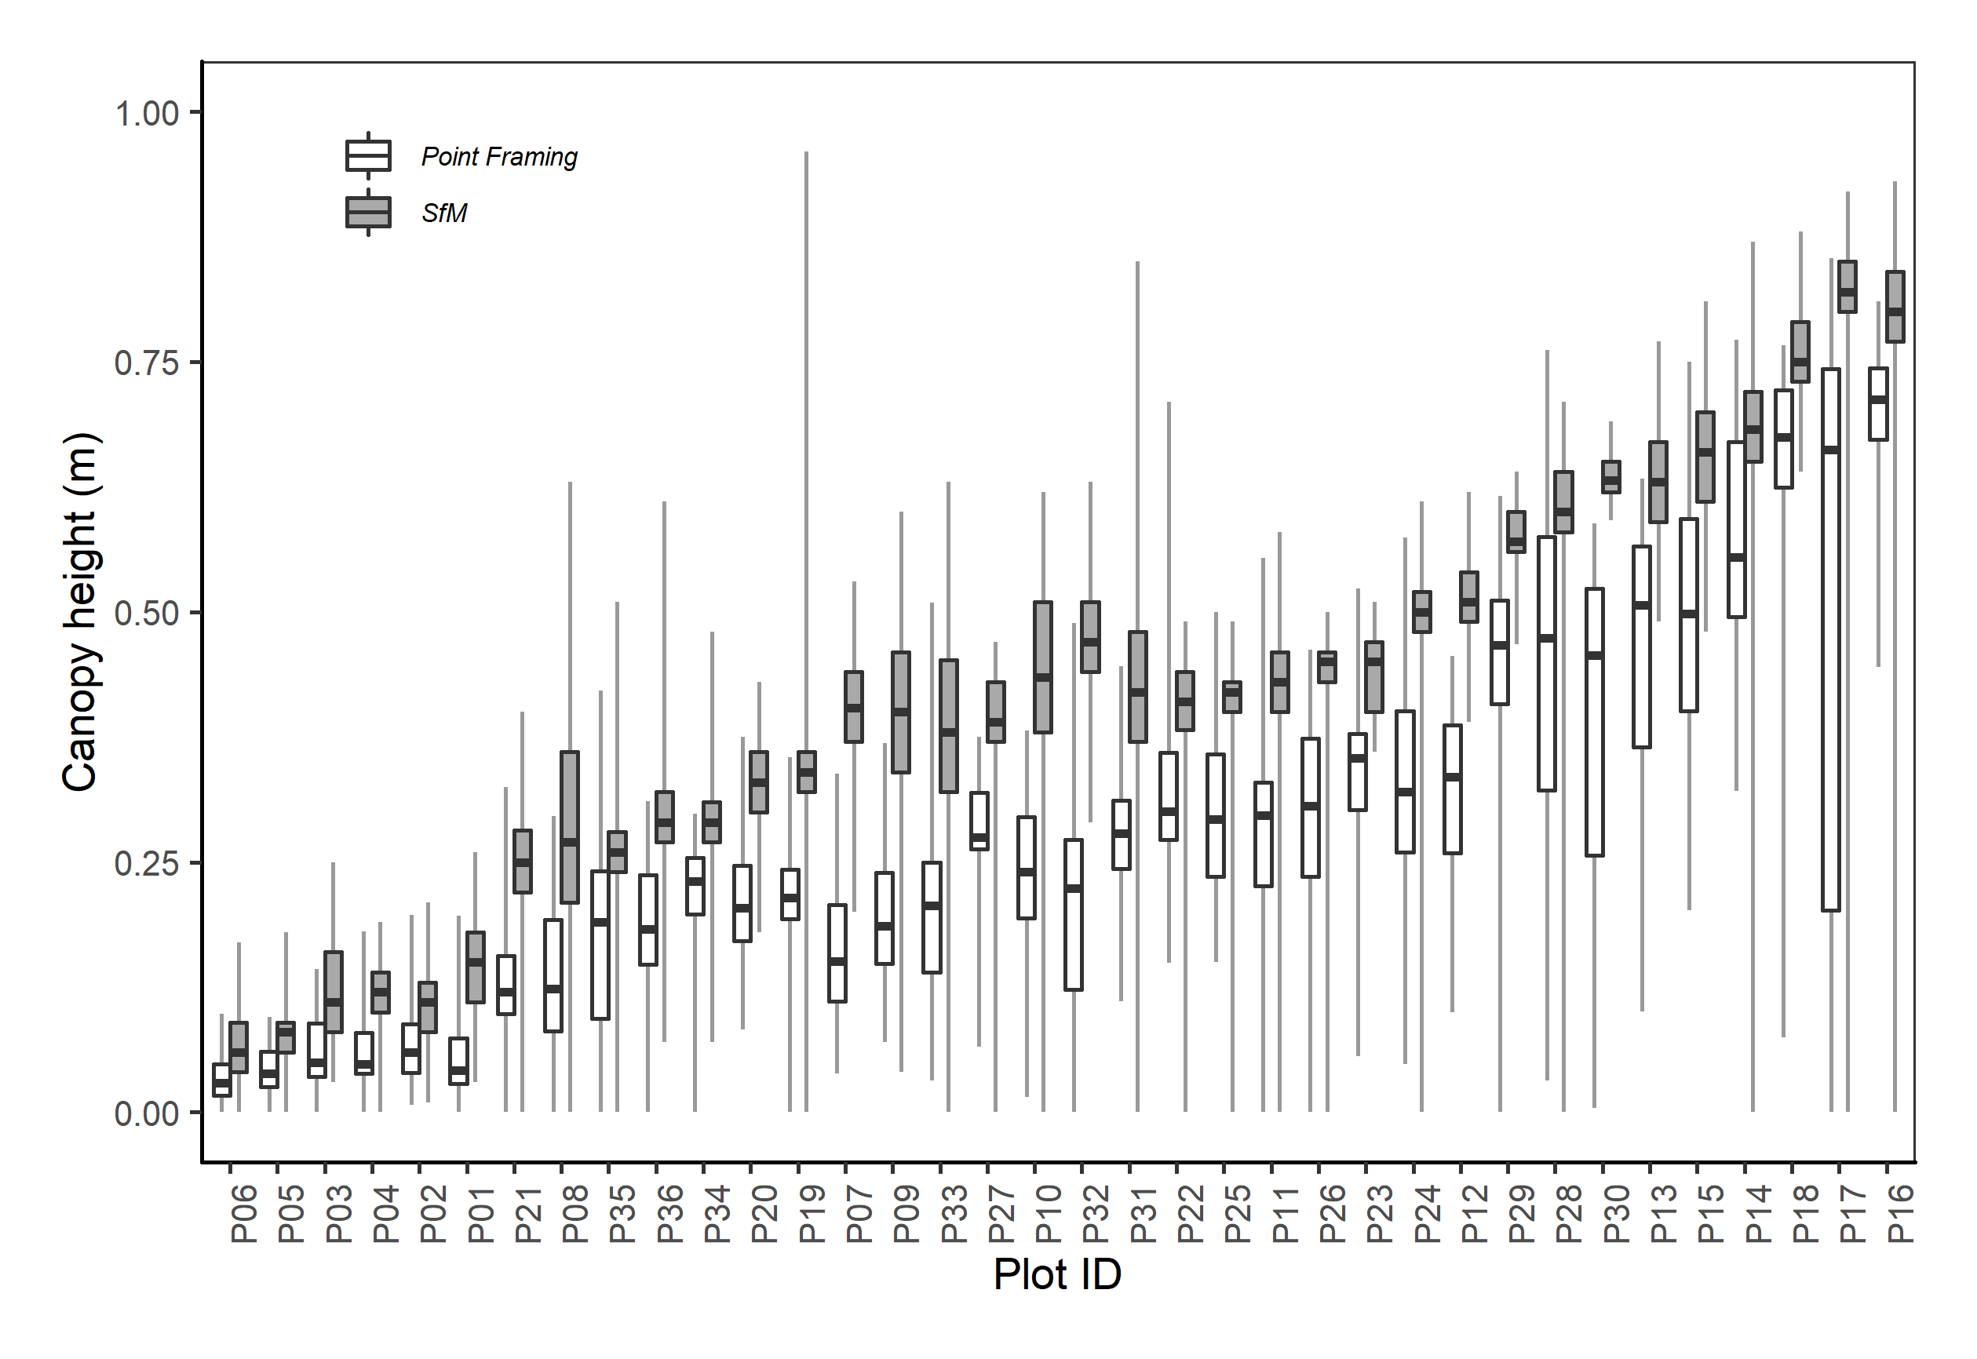

Figure S1. There is good agreement in canopy heights as observed with point framing (PF) and structure-from-motion photogrammetry (SfM) methods. Canopy heights measured with SfM were consistently positively biased relative to canopy heights measured with PF. The central bar indicates median canopy height, the shaded box indicates the interquartile range, and the whiskers indicate the maximum and minimum values.

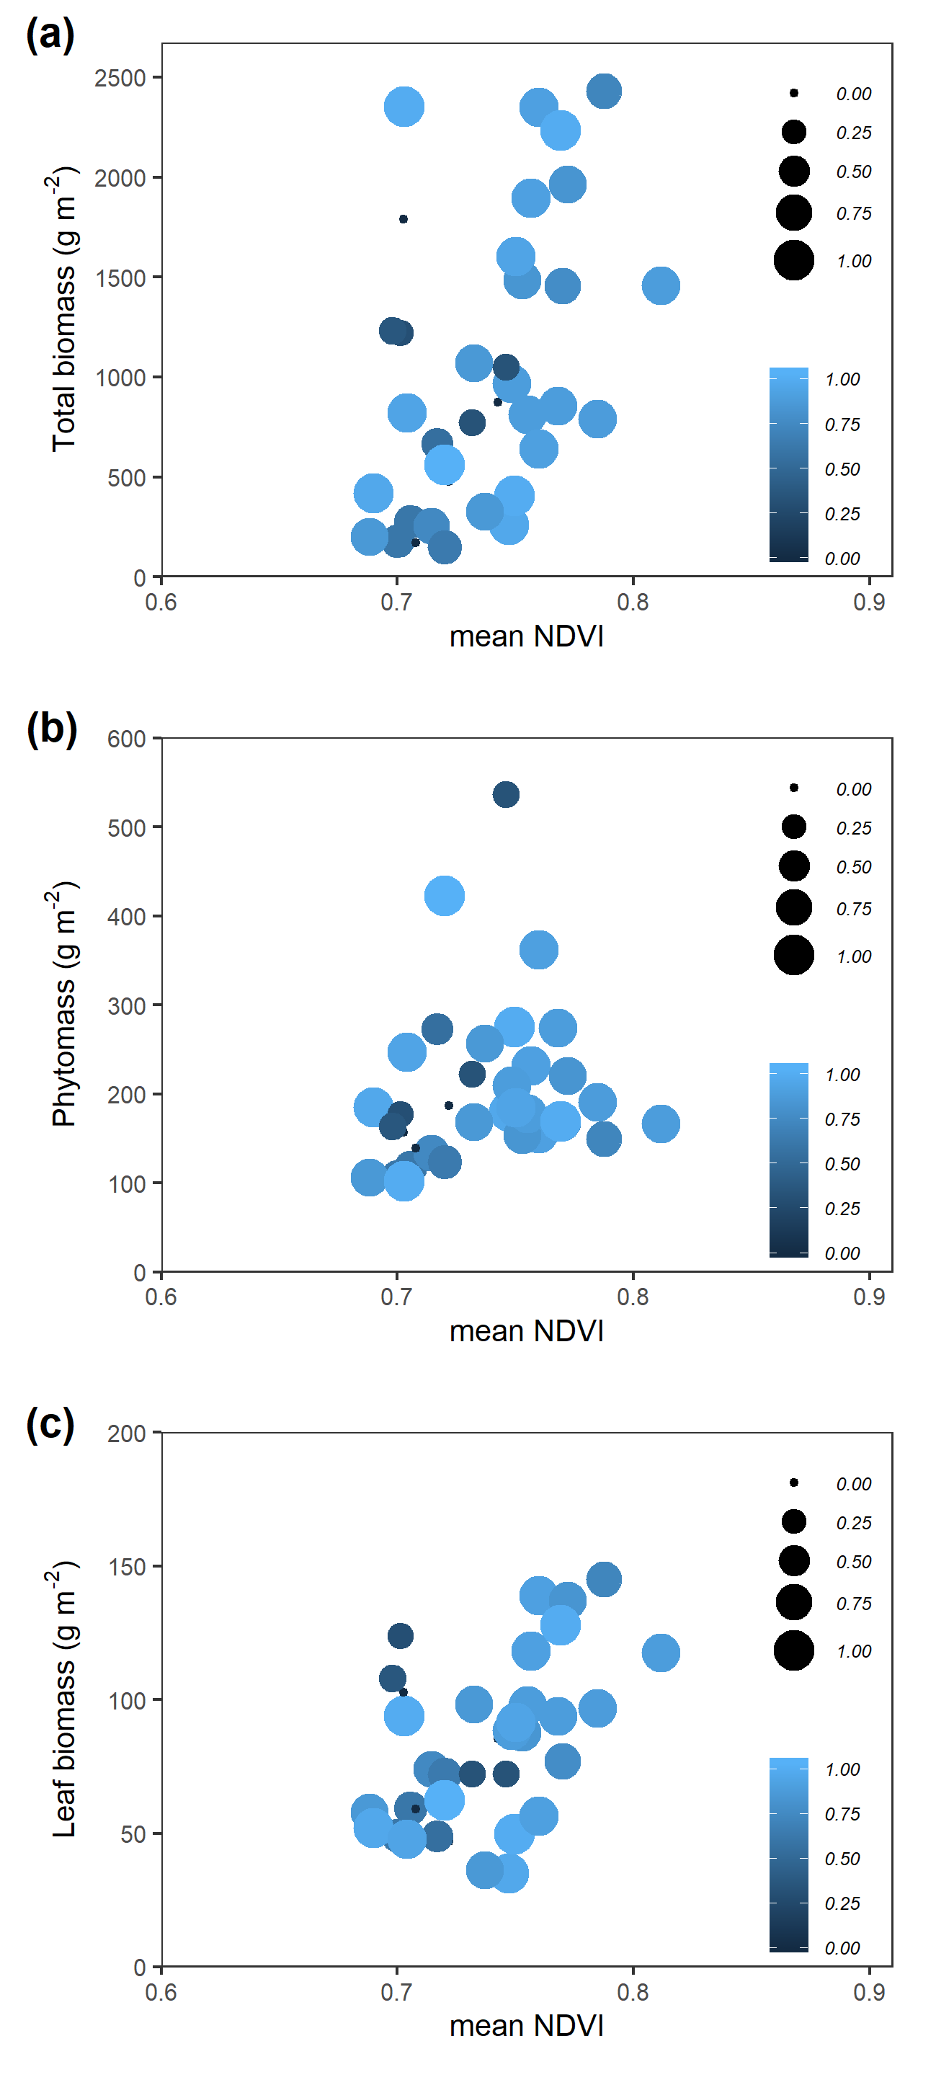

Figure S2. The proportion of moss observed in the point framing observations weakly influences the relationship between NDVI and biomass in all three pools (only data from the 0.121 m grain NDVI survey is illustrated here).